Risk Management Plan/Crisis Management Procedures for [FRATERNITY/SORORITY] at UConn

The following document should be used as guidance in your chapter, in conjunction with risk policies and guidelines provided by your national organization, for both risk mitigation and crisis response. Examples of such situations include, but are not limited to:

- Hazing

- Any injury or incident involving a member and/or a non-member at or during a chapter event, whether that event occurred on or off campus
- Any injury, illness or incident involving a member and/or a non-member.
- If a member has potentially contracted COVID-19, whether on or off campus
- The death or serious injury of a member (whether on or off campus)
It is important to note that this document provides guidelines for how to best mitigate risk for any and all chapter events and individual member activities. This document can also provide guidance on how you may act in a crisis situation. Your chapter should work with University Officials, the Center for Fraternity & Sorority Development, Chapter Advisors, Alumni, and Headquarters Staff to develop these plans thoroughly for preparation and in case of emergencies. This document is a great starting point for chapters and should be kept in a place that is accessible to all members. It should be updated and reviewed, continuously.

TABLE OF CONTENTS

  - GENERAL GUIDELINES Page 2

  - POINTS OF CONTACT. Page 3-4

  - PROTOCOL TO ASSESS RISK Page 5

  - RISK MANAGEMENT PLAN Page 6-7

  - CRISIS RESPONSE PLAN Page 8-9

  - SAMPLE CRISIS SITUATION Page 10- 11

  - BYSTANDER INTERVENTION PLAN Page 12

GENERAL GUIDELINES

- Each chapter should create and maintain a policy for both risk and crisis management.

o This document may be used as an outline for the creation of such a plan; however, it should be specific to each organization.

- The procedures and included documents should be maintained by designated officers as determined by the chapter, but at a minimum, should be maintained by the chapter risk manager and president.

- The crisis management procedures, chapter roster, chapter contact list, and emergency contact numbers should be maintained as part of this policy.

- Chapter may want to consider keeping emergency information cards on file for all members. You cannot mandate that members report medical information, however, it can assist responding units during emergency situations.

  - Keep on file with the president and risk manager an emergency information or sheet for each member and new member. Included on the card:

    - Member's full, legal name and birth date
    - Member's local address and phone number
    - Name, address, telephone numbers and email addresses of any emergency contacts. Be sure to include multiple spaces for more than 1 contact to be listed. Include relationship to member, home and/or cellular telephone numbers.
    - Medical information (allergies, medical conditions, medications, etc.)

- A copy of the policy should be maintained at a location known by all chapter members both inside and outside of the facility; i.e., with the chapter advisor (if local), at a near-by chapter (in case of fire and one of the copies being destroyed) or in the annex house (if applicable).

- It is also important to establish relationships with neighboring properties. Introduce yourself and provide neighbors with contact information for chapter leadership and a copy of your crisis management procedure.

POINTS OF CONTACT

CHAPTER PRESIDENT

Name: Phone:

RISK MANAGEMENT CHAIR
Name:
Phone:

[STUDENT LEADER POSITION]
Name:
Phone:

[STUDENT LEADER POSITION]
Name:
Phone:

CHAPTER ADVISOR

Name: Phone:

GRADUATE CHAPTER PRESIDENT / REGIONAL ADVISOR (IF APPLICABLE)
Phone:

NATIONAL HEADQUARTERS
Phone:

NATIONAL HAZING REPORTING HOTLINE
Phone: 1-888-668-4293

NATIONAL SUICIDE HOTLINE
Phone: 1-800-273-8255

COMMUNITY STANDARDS REFERRAL FORMS:
Link: https://community.uconn.edu/submit-a-referral/

ADDITIONAL SUGGESTED:

CENTER FOR FRATERNITY & SORORITY DEVELOPMENT
Contact your CFSD Chapter Coach and/or contact us the department at greeklife@uconn.edu
Ashley Christman, Director: ashley.christman@uconn.edu
Tori Succi, Assistant Director: tori.succi@uconn.edu
Jose Garcia, Coordinator: jose.s.garcia@uconn.edu
Cara Connor, Graduate Assistant: cjc21009work@uconn.edu
Sydney Jefferson, Graduate Assistant: srj22001work@uconn.edu

UCONN POLICE DEPARTMENT (NON-EMERGENCY)
Phone: 860-486-4800
Submit an anonymous tip: https://publicsafety.uconn.edu/police/police-services/reporting-records-victim-services/submit-an-anonymous-tip/

UCONN FIRE DEPARTMENT (NON-EMERGENCY)
Phone: 860-486-4925

STUDENT HEALTH & WELLNESS
Phone: 860-486-4700
Appointments: 860-486-2719

DEAN OF STUDENTS CARE TEAM:

Report: https://cm.maxient.com/reportingform.php?UnivofConnecticut&layout_id=3
Email: dos@uconn.edu

Protocol to Assess Risk:

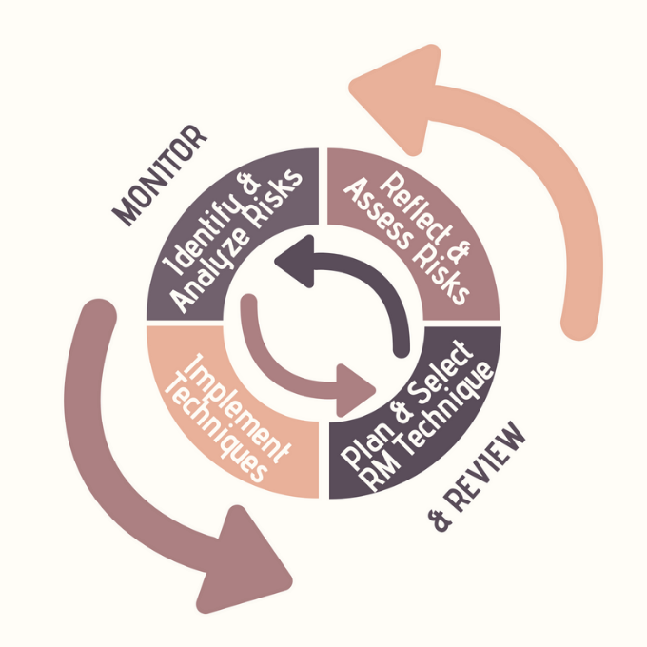

The Cycle of Risk Management:
- Identify & Analyze - Create a list of activities associated with your chapter and identify the risks associated with each activity
- Reflect & Assess - Use the list you created and ask yourself some questions about the scenarios in which each risk might occur.
  - Questions to Assess Risk:
    - When could this happen?
    - What is the likelihood of this happening?
    - Who does it impact?
    - What is the loss/harm at stake?
    - How severe is the risk?
    - Does it require immediate attention?
    - What is the reputational impact?
    - What should we do if this happens?
    - Who do we notify?
- Create a Risk Management Plan- different techniques are useful! Some risks require immediate repeated attention others require plans and strategies for situations that we hope won't arise. Communicating your risk management plan to your members is extremely critical and important.
- Implementation – Execute your risk management plan and take note.
- Monitor & Review – How well did your plan work? The cycle of risk management and your plan is an on-going and ever changing process.
  - Questions to reflect on in Monitor & Review:
    - Do we need to make a change to our plan?
    - Are there additional risks we didn't identify previously?

Risk Management Plan:

Some general activities that our chapter engages in are the following:

[Suggested Examples:]

Recruitment

New member education

Socials (mixers, date nights, etc.)

Parties

Philanthropy Events

Community Service

Semi Formals/Formals

Conferences

Networking Events

Alumni Activities

The risks associated with each our activities are the following:

[Insert Activity from list above]

[Insert Risk]

[Insert Risk]

[Insert Risk]

[Insert Activity from list above]

[Insert Risk]

[Insert Risk]

[Insert Risk]

[Insert Activity from list above]

[Insert Risk]

[Insert Risk]

[Insert Risk]

[Insert Activity from list above]

[Insert Risk]

[Insert Risk]

[Insert Risk]

[Insert Activity from list above]

[Insert Risk]

[Insert Risk]

[Insert Risk]

[Insert Activity from list above]

[Insert Risk]

[Insert Risk]

[Insert Risk]

The strategies we will implement to help us mitigate each risk are as follows:

[Insert Activity from list above]

[Insert Risk]

[Insert Strategy to Mitigate Risk]

[Insert Risk]

[Insert Strategy to Mitigate Risk]

[Insert Risk]

[Insert Strategy to Mitigate Risk]

[Insert Activity from list above]

[Insert Risk]

[Insert Strategy to Mitigate Risk]

[Insert Risk]

[Insert Strategy to Mitigate Risk]

[Insert Risk]

[Insert Strategy to Mitigate Risk]

[Insert Activity from list above]

[Insert Risk]

[Insert Strategy to Mitigate Risk]

[Insert Risk]

[Insert Strategy to Mitigate Risk]

[Insert Risk]

[Insert Strategy to Mitigate Risk]

[Insert Activity from list above]

[Insert Risk]

[Insert Strategy to Mitigate Risk]

[Insert Risk]

[Insert Strategy to Mitigate Risk]

[Insert Risk]

[Insert Strategy to Mitigate Risk]

[Insert Activity from list above]

[Insert Risk]

[Insert Strategy to Mitigate Risk]

[Insert Risk]

[Insert Strategy to Mitigate Risk]

[Insert Risk]

[Insert Strategy to Mitigate Risk]

CRISIS REPONSE PLAN

WHO IS IN CHARGE?

Suggested Text:
- Be sure that all members of the chapter understand that [POSITION(s)] are/is in charge of every emergency situation. The [POSITION(s)] should consult with other members who may possess more expertise or insight. However, the final decision rests with [POSITION(s)].

  - In the event that the [POSITION(s)] is/are absent, the next ranking officer assumes control which is [POSITION(s)]. All officers should know where to find a copy of the chapter’s crisis management procedure and emergency contact lists.
  - All new members should know who is in charge and be prepared to follow instructions laid out in the crisis management procedures. Include a review of the chapter’s crisis procedures in your fraternity/sorority new member education program each term.
  - In all situations, emergency response personal should be allowed to assume control of a situation. The chapter president or his/her/their designee should represent the chapter, but not interfere with any actions of emergency personnel or university officials.
  - It is important to note that the University of Connecticut has a Good Samaritan Statement in regards to calling medical services or personnel when a student is in need. Chapter members should be educated on and familiar with this statement.

PROCEDURES

- If a crisis occurs at an event in which the chapter is sponsoring the event, the chapter [POSITION(s)] should:
[Potential Example/Suggested: identify a common meeting place at once and give instructions to members. It is an expectation, however, to communicate with advisors, university officials, and responding officials.]

- In nearly all situations, the [POSITION(s) in charge from above] first call should be:
[Potential Example/Suggested: to 911. If the emergency situation is a fire, dial 911 or (local fire dept #). Do not hesitate to call the police regardless of the situation at 911. Briefly and calmly explain the situation so that the appropriate emergency personnel can respond.]

- After 911 is called, please make the following calls:
[Potential Example/Suggested:
- Notify someone in the Center for Fraternity & Sorority Development via e-mail or phone.
  - Your chapter advisor or a member of the House Corporation Board. Have a discussion with these individuals prior to any emergency situation and come to an agreement of who is to be notified. You should work with your advisor to notify appropriate members of your national headquarters staff so that they may offer support to the chapter.]

Some crisis situations that can occur are:

[Suggested Examples:]

Member Illness or Injury

Member contracts COVID-19

Student Death

Suicide/Attempted Suicide

Car Accident

Hazing

Fire

The protocol for each of the crisis situations are as follow:

[Insert Crisis from list above]

[Insert Step #1]

[Insert Step #2]

[Insert Step #3]

…

[Insert Crisis from list above]

[Insert Step #1]

[Insert Step #2]

[Insert Step #3]

…

[Insert Crisis from list above]

[Insert Step #1]

[Insert Step #2]

[Insert Step #3]

…

[Insert Crisis from list above]

[Insert Step #1]

[Insert Step #2]

[Insert Step #3]

…

PLEASE NOTE:

In any emergency, use extreme discretion and caution in your actions and statements. The realities of a crisis without a doubt can be gruesome and harsh. We would hope none of you ever need to use these procedures. If however, a tragedy does occur, following these procedures.

SAMPLE CRISIS SITUATION

Adopted from The Ohio State University Fraternity & Sorority Life Office

It’ early December and finals are upon us. Members of the chapter are up at all hours studying while others are blowing off steam in-between finals. At roughly 1 am, a fire breaks out within the kitchen of the off-campus house where many of your chapter members live. As the alarms sounds, members evacuate into the street. As they begin to gather outside, you as the chapter president know that you must take control of the situation. What do you need to do?

Following the plan we have outlined above…

- Someone should call 911 and report the fire in your house if this hasn’t already been done.
- You should have a designated area where all chapter members (or your roommates) are to meet if anything happens within your house.
- You should have access to your chapter roster, contact list, and house floor plan.
  - If you did not have a chance to grab it when you evacuated the building, you should have left a copy with your neighbors, with your advisors or even in your car.
- Take attendance at the designated location. We need to figure out if anyone is trapped in the house and where. This is of utmost priority as the rescue workers put out the flames and find anyone who is trapped in the building.
  - Who is not present?
  - For those who are missing, where are they?
    - Call cell phone numbers that you have on the contact list and determine locations.
    - Ask other members if they know of the locations of missing members.
      - Don’t take their word as completely factual as they may not know for sure. Their information should help you to locate anyone who may be missing.
  - Don’t allow anyone to leave yet.
- As the fire department and rescue workers arrive, introduce yourself as the president (allow them to do their job) and tell them that if you can assist in anyway, just have them ask. Let them know who is unaccounted for and where in the house their room is (use the floor plan).
- Once you have assisted the rescue workers and fire fighters in locating folks, begin your phone calls to other constituencies.
  - Chapter Advisor
  - University Advisors
    - The Center for Fraternity & Sorority Development will call other University folks as necessary.
  - Regional Advisor or Graduate Chapter Advisor if applicable.
- Determine your communication plan
  - The news media is going to be on-site quite quickly. They are going to want to talk to you or anyone from your chapter who is willing to say anything about what happened.
    - Work with your CFSD Advisor or Chapter advisor to put a statement together about the situation. DESIGNATE ONE PERSON TO TALK TO THE MEDIA. Make sure other members know that they should refer all inquiries to the designated person.
- Work to notify all members of the chapter, even those who live out of house. They should avoid coming to the location of the house as this will just add more traffic and folks to an already chaotic scene.
- Coordinate with University Officials and your Chapter Advisor to notify parents of the situation.
- If injuries or deaths have occurred, follow the communication plan described above for those situations.
- Once folks are accounted for, allow chapter members to head their separate ways. Some may want to go home as everyone deals with loss (even if just the house) in different ways.
  - Put a plan in place for checking in with everyone within the next 24-48 hours.
  - Work with University official to find alternative housing.
They should have begun this process already, but once things have settled, begin asking about it.

Bystander Intervention Plan & Protocol
As an organization, we are committed to keeping members and guests safe, at all times. One of the ways in which we commit ourselves to safety is through being active and healthy bystanders.

Bystander Intervention Education:
[Insert any education plans that are provided to the chapter]
[Suggested UConn Resource: https://dos.uconn.edu/protect-our-pack/]

Bystander Decision Making Model:
- Notice the Event- making sure members are aware of the issue or situation as it occurs. It is always best to err on the side of caution. If something does not feel right, it most likely isn’t.
- Decide: “Is this an emergency or problem?”- deciding how if something is an emergency or problem will better help determine how someone responds and intervenes. A problem (ie: a member hasn’t been showing up to chapter lately, a member has been excessively drinking more often lately and seems irritable) will require a different form of helping than an emergency (ie: someone becoming unresponsive due to severe intoxication, an injury, or physical altercation)
- Assume responsibility- the Bystander Effect is when the presence of others discourages an individual from intervening in an emergency situation. Basically? If you don’t do something about it, it is safe to assume that no one else is going to either. Most bystanders get to this stop and decide to do nothing because they assume someone else will. Wrong! You have to assume responsibility. There is also a good chance that if you are seeing the situation- others are too! So look around and ask a friend if they see what you see. Enlist others to help you.
- Decide how to help: Indirect or Direct- members need to remember that if a situation is unsafe or dangerous, they should not be putting themselves in harm’s way. It just means how they will help needs to look different. Also it is always a good idea to enlist others to help you in a situation of intervention. It is safer in numbers. Directly helping means you are inserting yourself into the situation and making it known that you are the bystander there to help. (Ie: distracting the perpetrator away from the potential victim). Direct ways of helping may occur more in emergency situations. Indirect ways of helping is intervening without making it known you are doing it (Ie: calling 911!). Indirect ways of helping may occur more in problems. See some examples below:

Direct:
- Removing person (potentially) at harm from the situation
- Distract- shift the perpetrator’s focus away from the situation
- Talk to the person involved directly about the situation or problem you see and ask how you can help
- Go with them to a UConn campus resource to help them make a report or seek help
Indirect:
- Call 911 (Imminent danger!)
- Seek help from professional or advisor
- Delegate! Bring in help, especially from fellow members or an authority figure to help you diffuse the situation behind the scenes
- Speak to a counselor or resource on campus about the situation
- Fill out a report through a UConn referral form
- Learn more yourself about how to help through campus resources:

- Intervene!

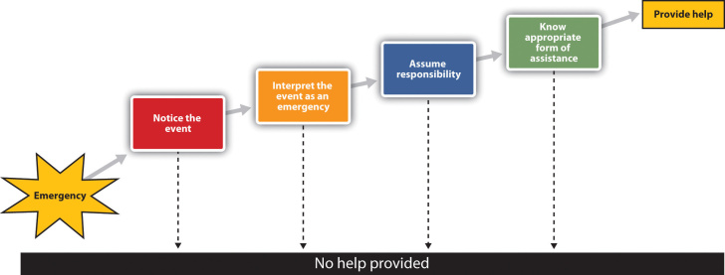

Some situations that may occur in which we will need to be active bystanders:

[Suggested Examples:]

Excessive Drinking

Sexual Harassment/Assault

Bullying

Drinking and Driving

Fights/Physical Altercations

Racist, Sexist, or harmful/targeting comments

The protocol for each of the situations are as follow:

[Insert situation from list above]

[Insert Step #1 for Bystander Intervention]

[Insert Step #2 for Bystander Intervention]

[Insert Step #3 for Bystander Intervention]

…

[Insert situation from list above]

[Insert Step #1 for Bystander Intervention]

[Insert Step #2 for Bystander Intervention]

[Insert Step #3 for Bystander Intervention]

…

[Insert situation from list above]

[Insert Step #1 for Bystander Intervention]

[Insert Step #2 for Bystander Intervention]

[Insert Step #3 for Bystander Intervention]

…

[Insert situation from list above]

[Insert Step #1 for Bystander Intervention]

[Insert Step #2 for Bystander Intervention]

[Insert Step #3 for Bystander Intervention]

…

SAMPLE BYSTANDER INTERVATION SITUATION

Adopted from NOMORE.ORG

You’re at a party or out drinking. Someone nearby has had a lot to drink and is being harassed or manipulated by someone you think may do something physically harmful to them. What do you do?

- Identify why you’re worried: If you see something that makes you uneasy, identify the behavior that worries you. Be direct and let the person know you are concerned and why: Is the person you are concerned about drinking too much, and are you afraid they might not be able to say no? Are you afraid that they won’t really be capable of giving consent?
- Consider whether to intervene: A situation doesn’t have to be dangerous for you to step in. Ask yourself: How might the situation affect the people who are involved? What’s the possible outcome?
- Enlist allies: This is key. There’s comfort in numbers. Enlisting allies, like a mutual friend, the bartender, party host or a bouncer can be much more productive and safer than trying to go it alone. Some ways you might handle the situation:
  - Consider asking if the potential victim needs help.
  - Don’t leave. By remaining present as a witness, the potential perpetrator is less likely to act.
  - If you know the potential perpetrator, ask him/her/them to leave the potential victim alone.
IMPORTANT: If you think intervening will put you in danger at any time, call 911 instead.

